**Square Gain Website**

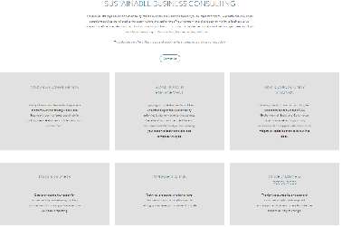

**General**

* Almost all traffic will by via PC/ laptop – hardly any by mobile phone.
* Keep scrolling down to a minimum and use all the space on the screen (e.g. by using grids)
* Retain the general format -blue and pink works well.
* Text: simplify and ensure 100% relevant…. Big simple statements…. Not just listing out all previous work
* Want to keep the website text high level so that we don’t need to update it too often Cookies – do we use them? Could we benefit from using them?
* The **website is a shop window** – NOT all the items in the shop. Aim – get visitors to make contact via email: provide **brief** info on our services and add more ‘Contact Us’ buttons so they can email for more info
* More click-throughs on the page to take directly to either more info/ contact us
* Note: As references for the refresh we’ve looked at a couple of sites for:
  + content: <https://www.carbontrust.com/>, <https://greenarchconsulting.com/>, [www.greengage-env.com](http://www.greengage-env.com), <https://xynteo.com/>.
  + Look and feel: [www.Apple.com](http://www.Apple.com), <https://carbon.ci/>, [www.rawstoneconsulting.co.uk](http://www.rawstoneconsulting.co.uk))
* We have three different audiences, with different interests/ focuses:

|  |  |
| --- | --- |
| * + Councils and NHS | * Data collection and analysis * Carbon policy and strategy * Carbon action plan – integrated across services * Internal training/ e-learning to build carbon competency * Greening supply chain * Carbon reporting |
| * + Big companies that supply (Tier 1) | * Net Zero Carbon implementation * Circular Economy * Winning work with clients * Internal training * Greening supply chain * Reporting |
| * + Small companies | * Net Zero Carbon – strategy/policy development and product measurement * Want to provide carbon footprint information to clients * May want light-touch training – mainly on what clients are asking for |

* **Knowledge Hub** (greenrecovery.co.uk): can we get this website launched (or point directly to Products and Services)? Same look and feel at Square Gain, but in hues of green (like you did before). We are thinking of having www.greenrecovery.co.uk /clientName web addresses to provide information specifically for particular council clients

**Navigation bar**

* Not much difference between ‘Projects’ and ‘Our Clients’ so think we can merge the two.
* Need to add ‘Contact Us’

|  |  |
| --- | --- |
| * + Map   [Wye - Google Maps](https://www.google.com/maps/place/Wye/@51.1801852,0.9393898,14z/data=!3m1!4b1!4m5!3m4!1s0x47dec55790d8f4f1:0xe479d7c0656fad49!8m2!3d51.181903!4d0.937883) | * First name * Last name * Email * Phone * Company * Position * Message * Submit button |

**Home page**

|  |  |
| --- | --- |
| **Text** | * **Advantage through sustainability**   + Company Sustainability   + Net Zero Carbon   + Circular Economy   + Training & e-Learning   We are a sustainability consultancy focused on the built environment, working in partnership with our public and private sector clients to deliver robust sustainable and commercial solutions, through a collaborative, pragmatic approach. |
| **Notes** | * Image needs changing so relevant to our services – probably use this one (via Pexels), perhaps with our services popping up * We could do with a Sustainable transport icon also (if you have one Rob).   Areal Photo of City Near River |

**Project/ client page**

|  |  |
| --- | --- |
| **Text** | Our Recent Projects and Clients  Projects include consultancy on net zero and wider sustainability, systems and product development, e-learning and training services. Selected recent projects are shown below |
| **Notes** | Change layout on Project Page – turn into a grid (square white boxes)– hover over the clients logo/ image to get the text (that is currently on the screen  Only selected clients have the hover over text. Other client logos are as per existing ‘Our Clients’ page |

**Services**

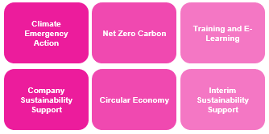

|  |  |  |
| --- | --- | --- |
| **Text** | **Grid titles** | **Hover-over text** |
| **Text (for each button)** | **Climate Emergency Action** | * We help local authorities to turn their Declarations of Climate Emergency into practical actions, that have stakeholder support and collaboration. * Find out more: We recognise the challenge of delivering practical action that receives local stakeholder support. As sustainability experts we have a successful track-record of doing just that for leading councils including Tower Hamlets, Hounslow and Hackney. * Contact Us |
| **Company Sustainability Support** | * If you’re unsure where to start with Sustainability and ESG, or what to include in your annual report or documents to clients, we can help.   + - * **Find out more:** More and more clients and investors are considering company sustainability credentials in their decisions of who to work with, or where to invest. We can help you capture and present the sustainability information they’re looking for in a structured, concise and effective way, to reflect your company at its best.   + Governance   + Strategy   + Stakeholder Engagement   + Action Plan Implementation   + Metrics and Data   + Reporting, Communication and Marketing * Contact Us |
| **Net Zero Carbon** | * Does your business need to take action on Net Zero targets and Carbon action, but you don’t know how? We explain what the most beneficial steps are for your company, and then help you implement them in a practical way. * **Find out more:**   + Governance   + Strategy and Scoping   } All to be developed later   * + Stakeholder Engagement   + Action Planning   + Implementation   + Metrics and Data   + Reporting * Contact Us |
| **Circular Economy** | * Have you heard of ‘Circular Economy’ but aren’t sure what it means for your business? We cut through the terminology to make it real for your company and implement practical actions. * **Find out more:**   + Strategy   } All to be developed later   * + Action planning   + Metrics and data   + Implementation   + Reporting * Contact Us |
| **Training & E-learning** | * Developing internal competence is a key part of organisational resilience. We provide training ranging from 30 minute catch-ups, through to detailed suites and training programmes over a period of months, all of which is available for Board Members to Operations. * Contact Us |
| **Interim Sustainability Support** | * If you’re not quite ready to hire a full-time sustainability staff member, then we can help fill the gap with flexible support provided by our experts. * Contact Us |
| **Notes** | * Use a grid rather than a list. * Use icons for each service – we already have these but they need to be brought up a level under our ‘services’ page * No longer using: sustainable finance, wellbeing, CR, Risk and Reporting, Supply chain risk management   I’ve developed a potential structure below, to replicate through each services when you click on it | |

**Ellen notes 2022 01**

Home page

This image seems quite random on the page. If it is relevant to SG then adding a caption below or a hover over project name would be more informative. Alternatively, could be an image of a project with a click navigation to take to the case study.

For clearer site navigation, could this ‘Contact Us’ button become a website header? Rather than generating an email pop up, it would be better to have a page with email/telephone contact information or even a contact form. *See next page.*

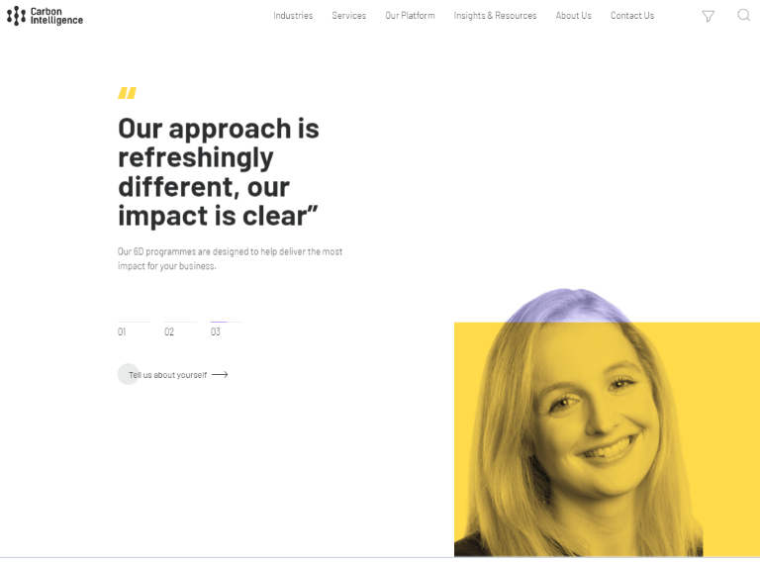

Better example – simple, bold and loops through three steps

*Images on the left are example contact pages from other competitors. The above image is the email pop up on SG website*.

If SG is hoping to gain clients through the website, it is crucial that the company is easy to contact. This would be improved with an actual ‘Contact Us’ page as demonstrated.

‘Who we are’

*The above images are screenshots from Greengage and Anthesis.*

Both websites present their team in a concise manner so that clients would not have to scroll down far to view who works there. If desired, you can click on the headshots to read more about the individual people. This could be something SG offers instead of having all associates in a long list. – EASIER TO NAVIGATE.

|  |  |
| --- | --- |
| Current Text | Updated Text |
| ‘Square Gain works in the public and private sector, and is focused on delivering practical sustainable solutions around carbon, energy, waste and sustainable finance. Our experienced team has a proven track-record to help our clients strategically and operationally. Established in 2015 by a group of experienced sustainability leaders, Square Gain has already worked with many leading organisations. Our Associates have over 150 years of sustainability leadership, working in local authorities, blue-chip multinationals SMEs, research and third sector organisations. We are a Cyber Essentials Certified company.’ | ‘Square Gain is a sustainability consultancy that delivers practical solutions to carbon, energy, waste and finance. We are an experienced team with a proven track-record to help local authorities, blue-chip multinationals, SMEs and research sector organisations on their journeys to Net Zero Carbon.’ |

Compared to the example websites above, SG website currently has lots of wasted space on the page. If the structure was altered so that each associates picture was next to each other (e.g., in 2 lines of 5 etc) it would look more balanced on the page.

This is a very rough example but, it demonstrates how placing pictures/icons in a row is a better use of space on each page, whilst also looking more professional. This example is on the ‘About Us’ page, but this same structure is transferable for the ‘Services’ and ‘Our Projects’.

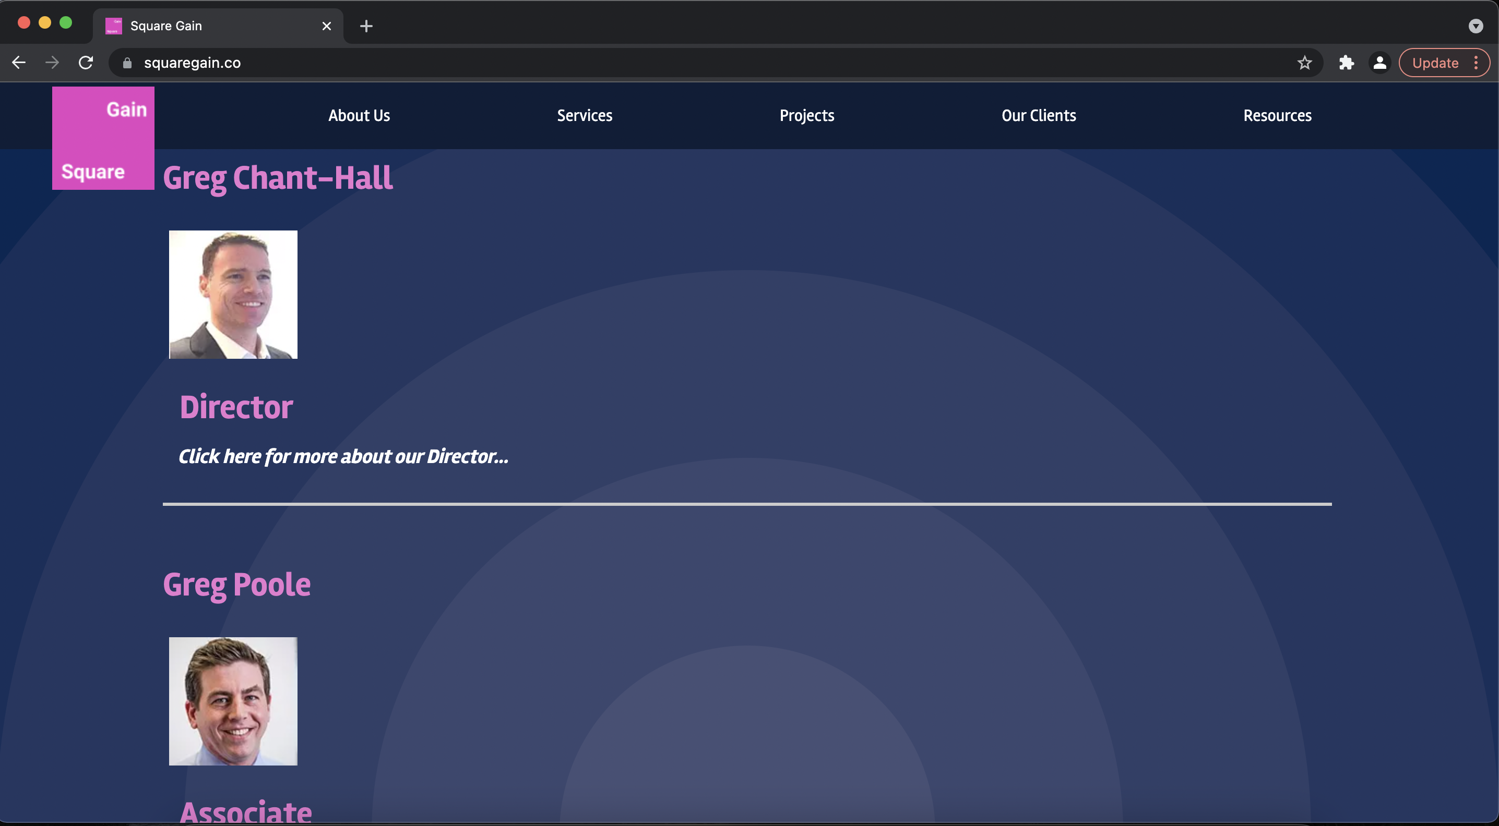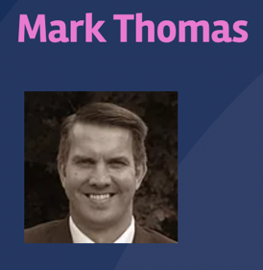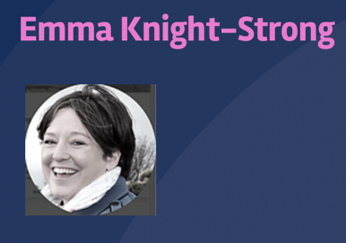

‘What we excel at’

*The above image is the SG website, top right is Carbon Intelligence and bottom right is Green Arch.*

Both websites to the right use small click on icons to demonstrate the services they offer. If clicked on, the text expands, and clients can read further information. Instead of SG having their drop-down text in a long list, it could be preferable to use the icons which appear when you click on the dropdown as the main button for each service. Not only would this make it more attractive, but a client on the website would be able to see all services without scrolling, as all services would be presented in a condensed grouping.

‘Projects’ and ‘Our Clients’

I think that the website would be much more concise if the ‘Projects’ page and the ‘Our Clients’ page were combined. Instead of having client feedback in a separate location this should be with the project case studies.

A singular ‘Projects’ page could have the logos of previous clients with a layout similar to how I have suggested both associates and services to be structured. Each logo could act as a button that would take you to the page with more detail on that specific project. I think this layout would look more professional (without the big white boxes), as well as not being a huge scrolling list.

*The two images on the left are how the website is currently structured with each client logo in a long white box with text underneath. The image below is a very rough example of how the website could look if you placed the logos next to each other so that there wasn’t a long scrolling list.*

*The images on the next page are an example website with this layout.*

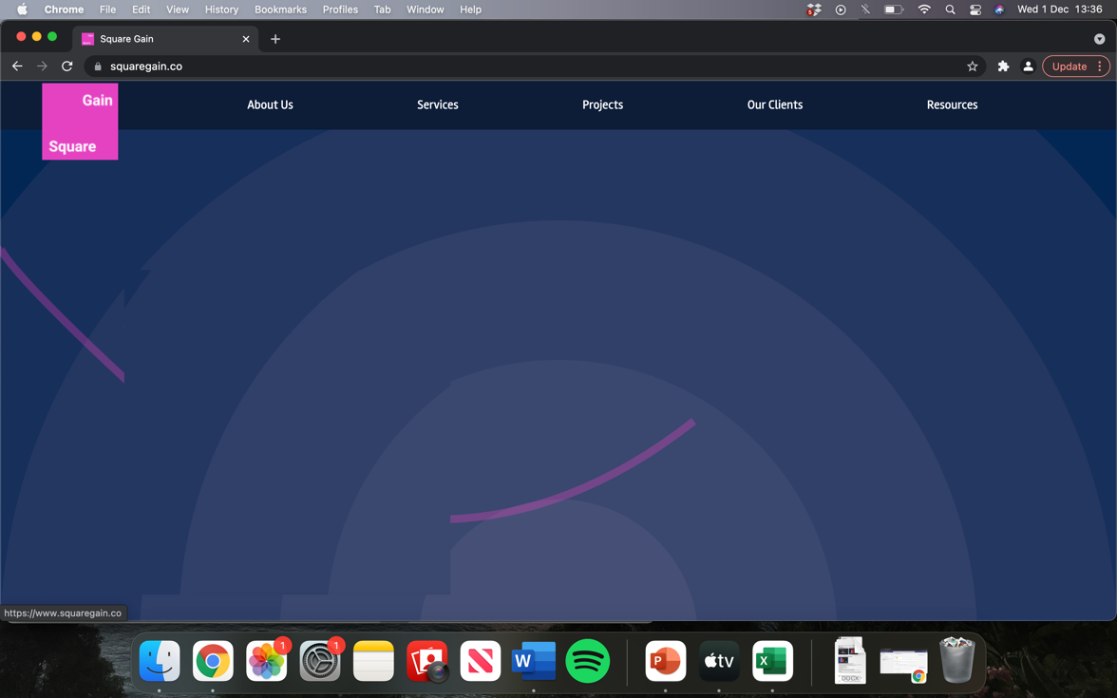

*This example to the left is not a sustainability consultancy, but I think the way they present their projects is aesthetically pleasing and transferable.*

The first image shows all the current projects the company is working on.

The second image shows when you hover over a specific photograph you get a caption/brief description of the project.

The third image shows that when you click on the image you are taken to a page that explains in detail the client, the project and the service which the company has provided. This is where SG could add to their website the customer feedback from the ‘Our Clients’ section. ‘Our Clients’ feedback doesn’t need to be its own button at the top of the website.

